How We Teach
Our learners know many things and they have gaps in their knowledge. We work together to find and fill those gaps. We also celebrate the knowledge they have. Our teachers are skilled and humble enough to teach well and admit to their own gaps.
Our learners want to understand why, when, and where to act, not just how to follow a checklist. We take the time to explain why. Then our learners apply what they learn thoughtfully, not just by rote.
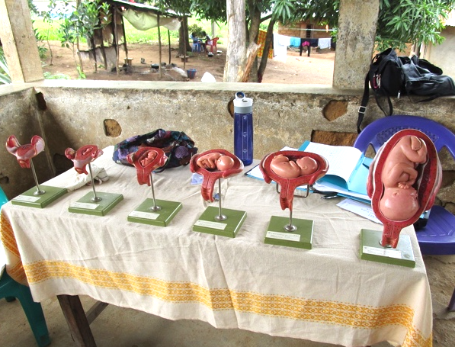
In addition to the whys of maternity care, we provide lots of practice and feedback to refine skills. Learners can connect their experiences to all we teach.
With our goal of building capacity, we encourage learners to change their communities. They learn to identify problems and implement solutions.
They also learn how to teach.
We teach through skits, dances, role plays, demonstrations, songs, and other active learning techniques.
Then the learners create songs and skits that they can teach others. It is no surprise to hear women working on their farms and singing about the benefits of breastfeeding or the best foods to eat when pregnant.
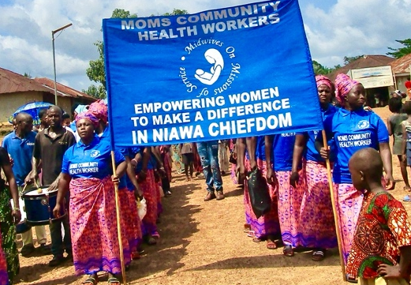
Learners marching to their graduation.
YOU CAN HELP!
You can make a difference!
We need to train more local trainers and provide more continuing education. This makes change that lasts!
Donate!
- Send checks to the address below.
- Visit MOMS-Midwives.org.
- Use the QR code below.
Help us raise money!
- Host an event featuring MOMS.
- Present our story to your church, service club, family, workplace, or other group.
- Help us write a grant application.
Volunteer!
- Join the Board of Directors.
- Help with correspondence.
- Search for resources.
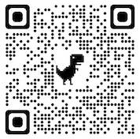
Zeffy is our favorite donation processor: No fees!
MOMS is a 501(c)(3) agency, EIN: 93-1254632
www.MOMS-Midwives.org  Trish@MOMS-Midwives.org  facebook.com/MOMSMidwives  PO Box 1656, Gualala, CA 95445  +1 707 884 3621 | 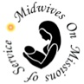
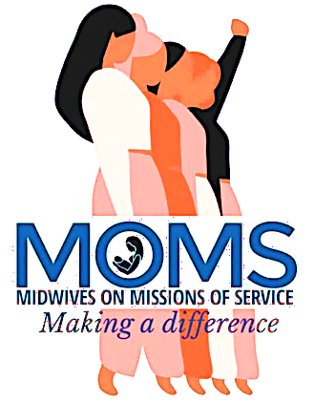
Since 2006, MOMS has worked in Sierra Leone, West Africa, in some of the most remote corners of the planet. MOMS works with women who are survivors in a hard place to survive.
We listen. We hear stories, told simply, of hiding from rebels, being raped, worrying about malaria and Ebola and HIV, fearing for their families. We hear stories of hunger, pain, disease, fear, and injustice.
The women also talk of hope for their children and even for themselves.
They are committed to changing, somehow, the world that has been so hard for them.
They take time from their family and farm – often to the family’s disapproval – to come learn. They study hard and ask many questions. Their hope of change draws them to us. Their goal? No woman should die unnecessarily in pregnancy and birth. Simple, but where maternal mortality is about 2%, change is desperately needed.
We teach. We teach change agency and maternal health care.
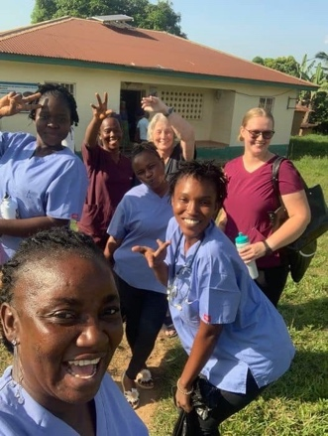
MOMS training team, Ngiehun, November 2023
Who MOMS Is
MOMS is a humanitarian agency aiming to improve maternal and infant health through education and service. The educating and serving is to help women use their voices and hands capably. MOMS focuses on those with fewest choices.
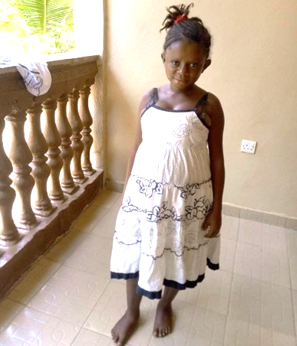
We housed this 11-year old child till she safely recuperated from surgical delivery. She and her child are both safe. She asked us to use this photo.
MOMS is a 501(c)(3) nonprofit and is registered in Sierra Leone. Our value on respect extends to our governments.
MOMS is run by volunteers.
In Sierra Leone, we pay our managers. We pay our trainers – whom we carefully train, test, and certify. We also cover expenses for our Leadership Council members.
They all work because they are committed to making change that lasts.
MOMS is our learners: the women of Sierra Leone. Our students survived living in the epicenter of the "blood diamond" war and Ebola. The survivors must be agents for change, to improve their lives now and to build capacity to survive future crises.
What MOMS Does
We teach. We have made 25 trips to Sierra Leone and trained about 780 women to make a difference, so far!
Maternal and infant mortality rates dropped. Families space their children. They apply principles of good nutrition to avoid anemia, kwashiorkor, and other diseases. Entire villages are cleaner. MOMS community health workers (CHW) make a difference.
Ebola, then COVID-19, temporarily closed Sierra Leone, yet MOMS CHWs used what they learned and taught others. Government officials said, “MOMS’ Health Workers played a pivotal role.” And they said, “Please come back soon. We need you.”
In addition to certifying CHWs, we support a Leadership Council. Each class elects a delegate to the Council. They set priorities, solve problems, and give nuanced advice. They meet regularly with our staff, and return home to teach.
We are intentional about preparing trainers who excel. All MOMS classes, regardless of who teaches, receive consistent, effective, and enjoyable teaching from skilled trainers on current, accurate material.
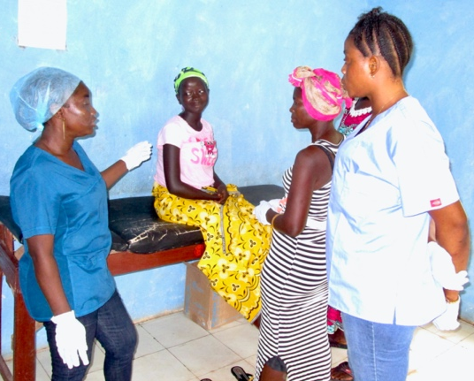
Jitta Rogers Seisay is teaching prenatal care.
Our leadership also receive training on management skills.
Our plans
More people ask us to teach than we can handle. The need is real, and we want to meet the need. Yet, we cannot risk the quality of the program to meet the quantity of the need. This work, to be so effective, takes money and time.
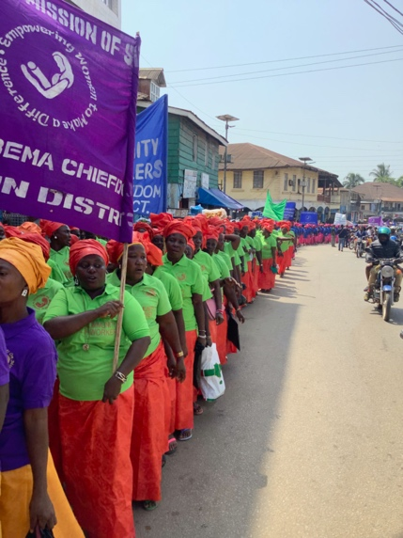
Jamboree 2023! 525 of us sang and danced through town. Onlookers were happy for us.
In Spring of 23, we started a new class of local trainers. This lets us widen our reach into new areas, while deepening our existing relationships.
In Fall 23, they practiced teaching while MOMS Education Director and Training Manager supervised closely. We hope to certify them in 2024. Then we will expand beyond the four Districts where we now work.
We have much to do.
First: Raise money to finish the train-the-trainer sessions and to fund teaching new classes. We cannot let our momentum fade.
Second: Strengthen our relationships with government officials. This requires us to return again and again, to ensure clarity about our commitment.
Third: Continue recruiting board members to help us reach our audacious goal of creating sustainable, respectful healthcare for all women, in even the most remote areas of the world.

